**Zheng Zhang, Jana AlHuneidi, Gabrielle Hladik, Garth Crawford**

**ECE 212**

**Professor Holtzman**

**July 5th, 2020**

**Initial Sprint Plan**

**Goal:**

In the next two weeks, our goal is to build a complete watch, which can be comfortably placed on the wrist like a regular watch and uses the LCD for the 12-clock display. We will begin to prepare for the second sprint to remind the user to wash their hand.

**Product Backlog**

* Research project requirements
  + Best hardware components (microcontroller, LCD screens, etc.)
  + Best sealants
  + bluetooth/cloud capabilities
  + battery/charging capabilities
* Program Clock interface
* Program notification/reminder system
* Program Timer
* Program Vibration sensor
* Program LCD screen Display
* Build circuit of watch
* Order components for circuit
* program /Add bluetooth or the cloud to a device to collect the data

**Tasks Checklist**

| **Task** | **Assigned to** |
| --- | --- |
| Order/receive components for watch | Garth |
| Build Circuit for watch | Garth |
| Program time watchface  Program Notification system | Jana, Zheng, Gabrielle |
| Test Code with watch | Garth |
| Debugging the code of sprint 1 | Jana, Zheng, Gabrielle |
| Create Model & 3D print Components for Prototype | Gabrielle |
| Research Notification System Approach | All |
| Research best components to use | All |

**Trello board**

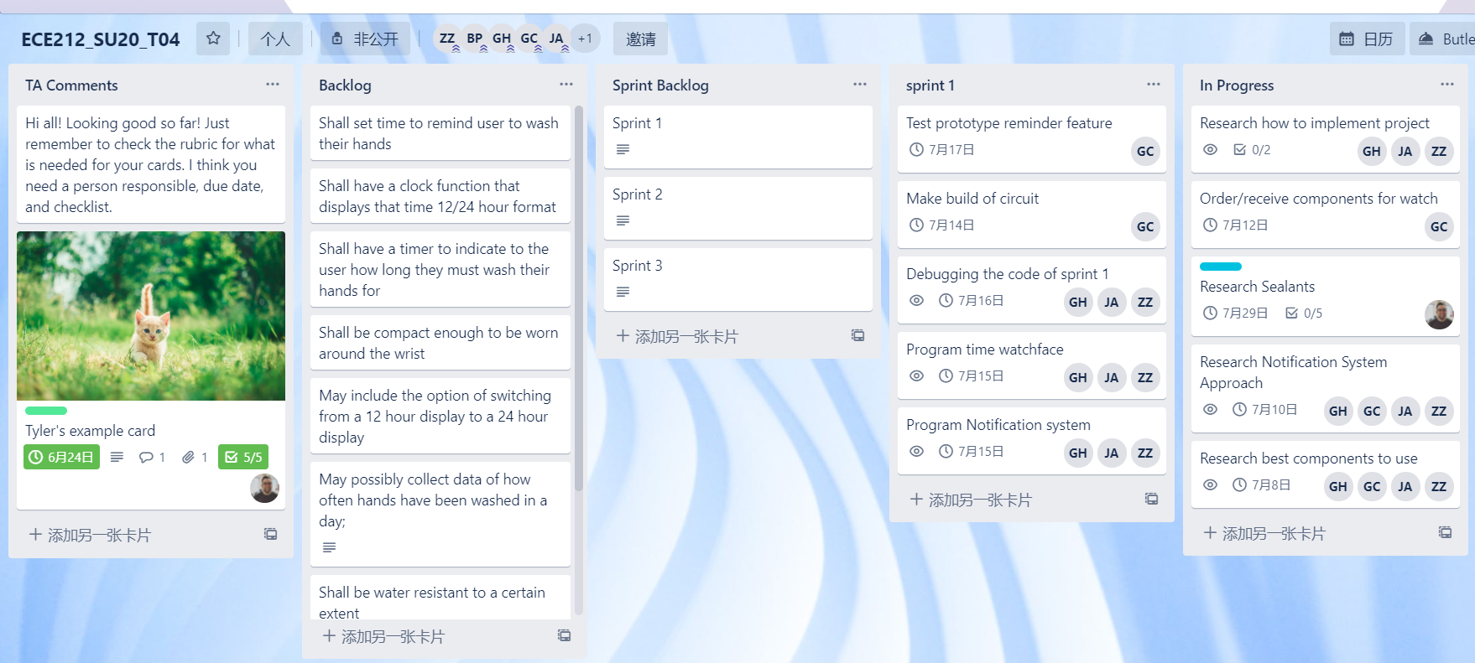

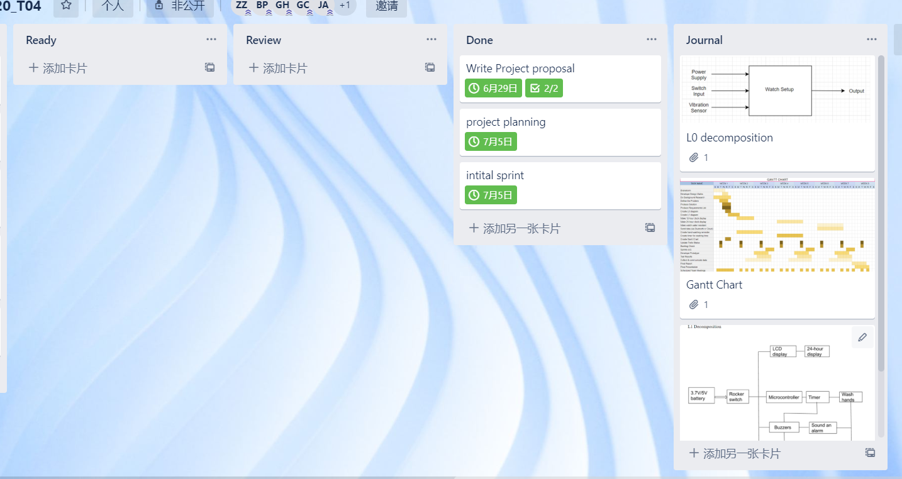

For the following sprint, our highest priority is creating a functioning program that shows the time on the watchface. This will be the first step towards building the watch. Our next priority would be ordering the components in order to commence building the circuit. This is important as we will need to check if the code actually does work with the microcontroller after the debugging stage. However, this will begin once we have finished our initial research process for the best way to proceed and the best components to use.

We decided to divide the tasks based on the strengths and weaknesses of each team member. With this in mind, Garth will be building the circuit and ordering the components while the other team members (Jana, Zhang and Gabrielle) will program and debug the code for the watch. Once the code is written, Garth will test everyone’s code to ensure functionality, noting if there are any issues with the program. In the instance where Garth needs to debug the code himself, one, if not all, of the group members will help him and walk him through this. In addition, everyone must participate in the discussion of the project, such as Research best components to use and the best way to approach the project. This will enable everyone to equally participate in the project. WIth that, we also had Gabrielle create the 3D model of our watch case after we decided which components will be needed as well as how they will fit. Once the model was made in Autodesk Inventor, Gabrielle sent the files to Tyler to have 3D printed for our prototype.

*We have reviewed this Sprint Plan with our Scrum Master Tyler Hull. All team members have contributed to this report, read it ,and agree with its contents.*